Obituaries
Famous Characters in the Early Years of the
United States History

Abraham Lincoln
b. February 12, 1809
d. April 15, 1865
Lincoln was the 16th President of the United States. He issued the Emancipation Proclamation, and was president during the Civil War.
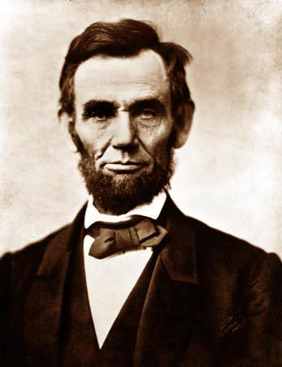

John Wilkes Booth
b. May 10, 1835
d. April 26, 1865
Booth assassinated President Lincoln just days after the Civil War ended. He shot him at Ford’s Theater.
